Instruction Manual

Enterprise Pro
Team 16

Tawfeeq Hussain 24000557
Ibraheim Hussain 24003673
Siraaj Ali 24002882
Fayzaan Khan 24039463
Victor Nwagu 23045806
Elysia Horder 24044847

Contents

Complete Application User Guide 2
Format/File Sizes 4
How to Add and Repair HTML/CSS 6
How to Add Hyperlinks in HTML 8
How to Repair Layouts in HTML/CSS 8
Working with SQL Databases 9
Viewing and Editing HTML/CSS Code 10
Troubleshooting Tips 11
How To Use Xampp 12

Complete Application User Guide

This guide explains how to open, use, and edit the application in a simple and beginner-friendly way. It is designed for users who may have little or no experience with HTML, CSS, or SQL.
The application may be a basic website made with HTML and CSS, or it may include a local server and database for extra features. In this guide, you will learn how to open the project, move through the pages, make basic changes, work with tables and hyperlinks, adjust layouts and colours, and manage simple SQL database tasks.
The aim of this user guide is to help you understand the main parts of the application and give you clear instructions for making updates safely and with confidence.

- Accessing the Application (Local server Setup):
To access the final software, please follow these steps carefully:

Step 1: Create a Project Folder
- Create a new folder on your desktop or in your personal local area.
- Name it something suitable, for example: final_sof.

Step 2: Download the Project Files
- Go to the GitHub folder named Final Software.
- Download all files.
- Save them inside the final_sof folder you created.
- If you already have the project files saved locally, you’ve completed step 2.

Step 3: Install XAMPP
- Make sure you have XAMPP installed.
- If not, download it here: https://www.apachefriends.org/download.html

Step 4: Move Files to htdocs
- Open File Explorer and go to: This PC Local Disk → xampp → htdocs
- Copy your project folder (final_sof for example).
- Paste it inside the htdocs folder.

Step 5: Start the Server
- Open the XAMPP Control Panel.
- Start Apache.
- Click Admin next to Apache.
- Your browser may open a page like: http://localhost:8083/dashboard/

Step 6: Open the Application
- In the browser address bar, replace dashboard with your folder name:
http://localhost:8083/final_sof/page1.html

Step 7: Set Up the Databases
- Go back to XAMPP.
- Click Admin next to MySQL.
- This will open phpMyAdmin.
Create the first database:
- Click New
- Name the database: Staff
- Click Create
- Go to the Import tab
- Select the file staff.sql (from your project folder)
- Click Go
Create the second database:
- Click New
- Name the database: sources
- Click Create
- Go to the Import tab
- Select the file sources_db_onedrive.sql
- Click Go

Step 8: Launch the Website
- Open your browser and go to: http://localhost:8083/final_sof/page1.html, or replace final_sof with the correct name of your folder.

Important Notes
- The Staff database must be created and imported correctly, or the staff page will not work.
- The sources database must also be set up properly for its page to function.

- Navigating through the Pages:
Once the website is open, you can move between pages by clicking:
- buttons
- menu links
- text links
- links that contain images
These links are added in the HTML code.
Example:
html
<a href=”page2a.html”>Go to Page 2a</a>
This creates a clickable link that opens page2a.html.

- How to Make Changes:
If you want to change something on the website, such as:
- text
- images
- tables
- colours
- layout
You will need to open the project files in a text editor.
Recommended text editors:
- Notepad
- Notepad++
- Visual Studio Code (VS Code)
Steps:
- Open the file you want to edit
- Make your changes
- Save the file
- Refresh the browser to see the update

Format/File Sizes

- What Formats are Best for HTML/CSS applications?
For this application, which uses a local server, the main file types include
- HTML – structures the content of the website
- CSS – controls layout, design, and appearance
- JavaScript – adds interactivity (if required)
- PHP – handles server-side processing (e.g., form handling, database connections)
- SQL – used to store, manage, and retrieve data in databases
- Role of PHP and SQL
- PHP files (.php) run on the server (via XAMPP) and are used to:
Connect to databases
Process user input
Display dynamic content
- SQL files (.sql) are used to:
Create databases and tables
Store structured data (e.g., staff records, sources)
Import data into systems like phpMyAdmin
- These files are essential for the full functionality of the application and must be correctly set up in the local server environment.

- Converting Existing File Types
The files currently used (Word, Excel, PDF, JPEG) need to be adapted for web use:
- Word (.docx)
  - Cannot be used directly
  - Content should be copied into HTML or converted to PDF
- Excel (.xlsx)
  - Cannot be used directly
  - Data should be converted into HTML tables or CSV
- PDF (.pdf)
  - Suitable for large documents (e.g., logbooks)
  - Should be provided as downloadable links
- Images (JPEG, PNG, GIF)
  - Suitable for displaying visuals on web pages

Recommended Image Formats
- JPEG / JPG – best for photographs (smaller file size)
- PNG – best for graphics and transparency
- GIF – best for simple animations

File Size Guidelines
Images
- Icons/small graphics: 10 KB – 100 KB
- Standard images: 100 KB – 500 KB
- Large images: under 1 MB
Large images can slow down the website, while very small images may lose quality.

Tools to reduce image size:
- Photoshop
- Paint.net

In Photoshop:
- Go to File > Save for Web
- Lower the quality slightly to reduce file size

In Paint.net:
- Go to Image > Resize
- Make the image smaller if needed

How to Add and Repair HTML/CSS

- Creating a New Table:
If you want to add a table to your webpage, use HTML like this:
<table>
<tr>
<th>Table Header 1</th>
<th>Table Header 2</th>
</tr>

<tr>
<td>Row 1, Cell 1</td>
<td>Row 1, Cell 2</td>
</tr>

<tr>
<td>Row 2, Cell 1</td>
<td>Row 2, Cell 2</td>
</tr>
</table>

What this means:
- <table> starts the table
- <tr> creates a row
- <th> creates a heading cell
- <td> creates a normal cell
Add the table inside the <body> section of your HTML file.

- Adding Table Numbers to Tables:
You can give your table a title by using the <caption> tag.

<table>
<caption>Table 1: Example Table</caption>
<tr>
<th>Header 1</th>
<th>Header 2</th>
</tr>
</table>
This will display a title above the table.

- Adding Hyperlinks to Table Page Numbers:
You can place a hyperlink inside a table cell.
Example:

<table>
<tr>
<td><a href="page2a.html">Go to Page 2a</a></td>
</tr>
</table>
This makes the text clickable.

- Adding or Deleting Rows in a Table:
To add a row:
Copy and paste another <tr> section

<tr>
<td>New Row, Cell 1</td>
<td>New Row, Cell 2</td>
</tr>

To delete a row:
Remove the whole <tr>...</tr> block for that row.

How to Add Hyperlinks in HTML

If you want a word or sentence to open an image, use this:
<a href="images/myimage.jpg">Click here to view the image</a>
Important:
Make sure:
- the image is inside the correct folder
- the file name is correct
- the file path matches your folder structure
For example, if your image is inside a folder called images, the link should point there.

How to Repair Layouts in HTML/CSS

- Changing the Size section
If you want to make an area bigger or smaller, use CSS
Example
.noteable-dates {
width: 400px;
height: 300px;
}
.picture-area {
width: 600px;
height: 400px;
}
What this does:
- width changes how wide the area is
- height changes how tall the area is
You can place this code:
- inside a <style> section in the HTML file, or
- in a separate .css file
- Changing Colours:
You can change colours using CSS

Example
body {
background-color: #f0f0f0;
}

.text {
color: #333333;
}
What this means:
- background-color changes the page background
- color changes the text colour
Important note:
The correct CSS spelling is:
- background-color
- color
Note:
- background-colour
- colour
(Those spellings are common in UK English, but CSS uses American spelling.)
You can use:
- colour names like red, blue, green
- hex codes like #ffffff or #333333

Working with SQL Databases

- Adding, Amending, or Deleting Records:
To add a record
INSERT INTO table_name (column1, column2)
VALUES ('value1', 'value2');

To update a record (UPDATE):
UPDATE table_name
SET column1 = 'new_value'
WHERE column2 = 'condition';

To delete a record (DELETE):
DELETE FROM table_name
WHERE column_name = 'value';

- Changing column Name:
To rename a column in SQL:
ALTER TABLE table_name
CHANGE old_column_name new_column_name column_definition;

Note:
The exact command can vary depending on which database system you use (for example, MySQL, SQL Server, PostgreSQL).

- Changing Colours in SQL:
SQL does not control webpage colours directly
Colours are usually controlled in:
- HTML
- CSS
- JavaScript

However, SQL can store colour values such as:
- #ffffff
- #000000
Your website code can then read those values and apply them.

Viewing and Editing HTML/CSS Code

- How to View HTML/CSS Code:
To see the website code:
- Find the .html or .css file
- Right-click and choose Open with
- Select a text editor such as:
  - Notepad
  - Notepad++
  - VS Code
What you will see:
HTML contains tags such as:
- <div>
- <p>
- <table>
- <a>

CSS contains style rules such as:
- color
- font-size
- background-color
- margin

Troubleshooting Tips

If the page does not open:
- Make sure you opened the correct .html file
- Check that your browser is working
- If using XAMPP, make sure Apache is running
If images do not appear:
- Check the image file name
- Check the folder location
- Make sure the file path is correct

If styles do not show:
- Check that the CSS file is linked properly
- Refresh the page
- Make sure the CSS code has no spelling mistakes

If database changes do not work:
- Make sure MySQL or your database server is running
- Check that your SQL syntax is correct
- Back up your database before making changes

How To Use Xampp

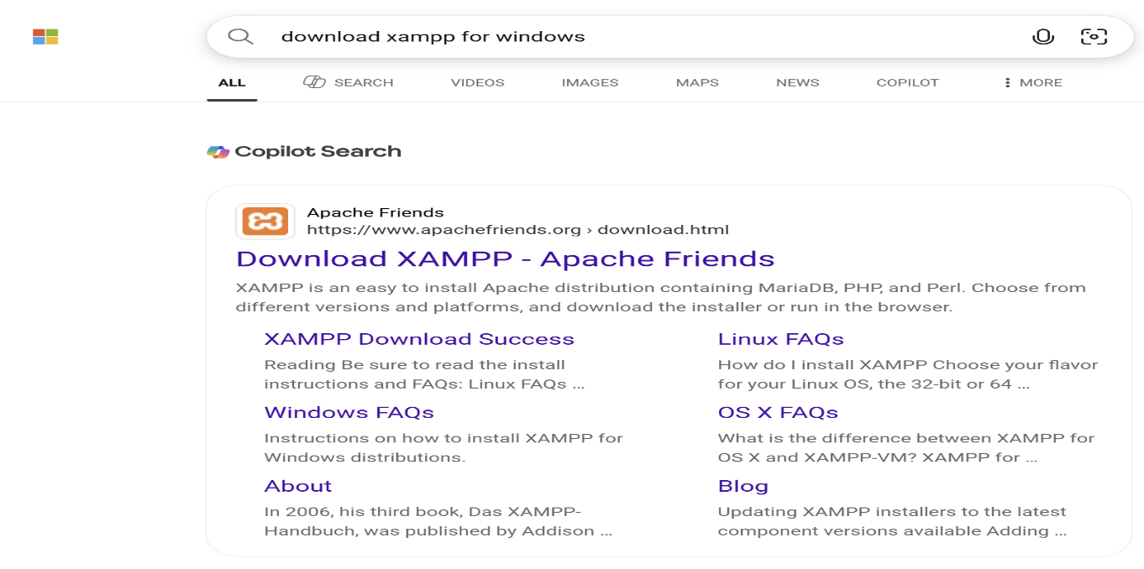
- In google search for “download xampp for windows” and open the first link that says download xampp

- Then click on 64 bits XAMPP for windows
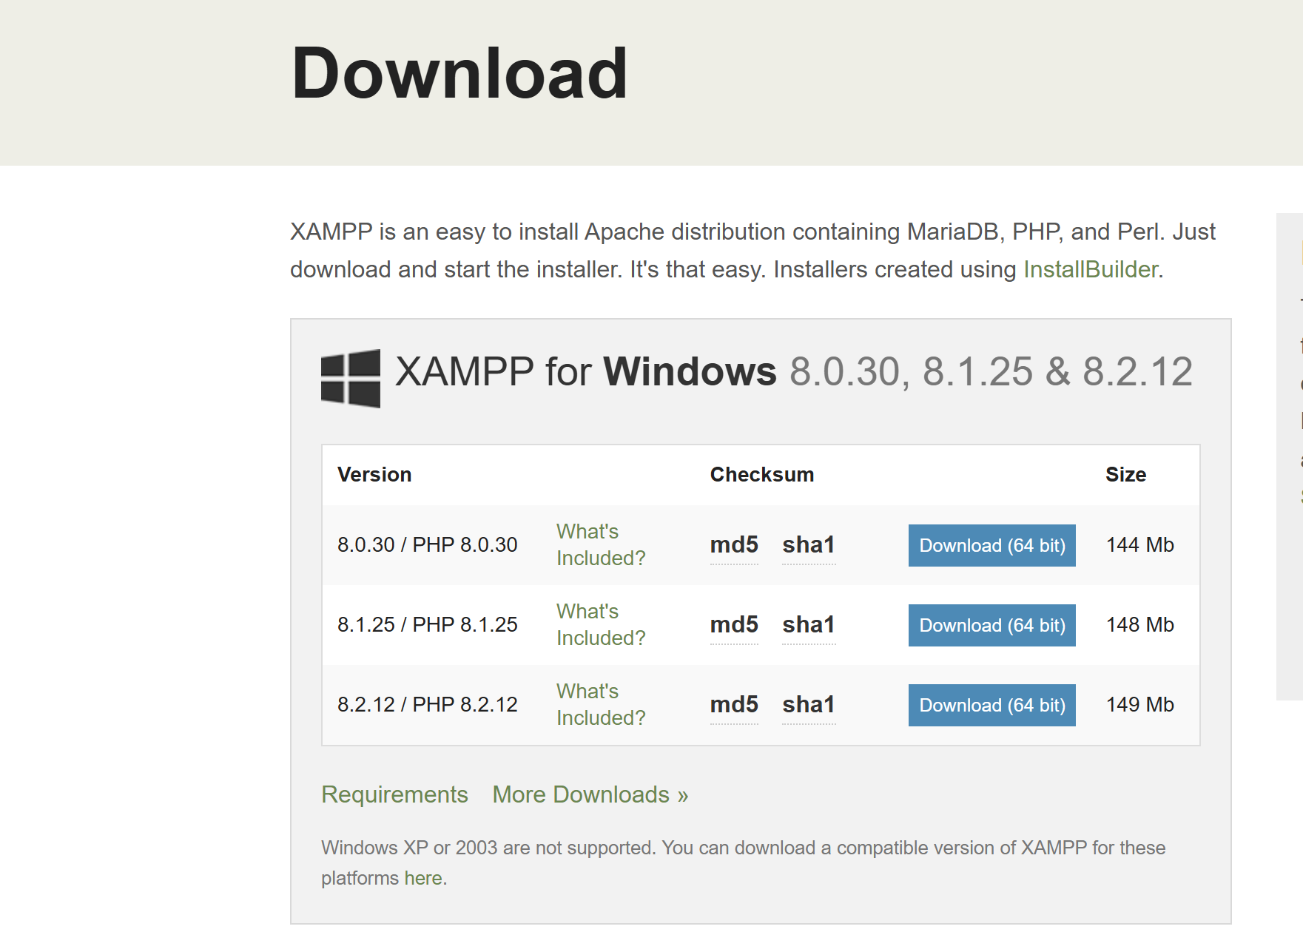

- Once the download is complete double click on the file to run xampp
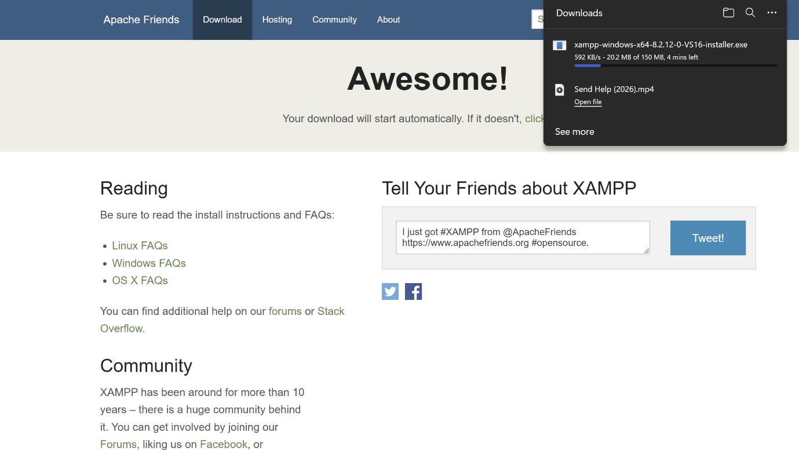
- after the installation provide some permission to make it work
- choose the folder where you want xampp to be stored

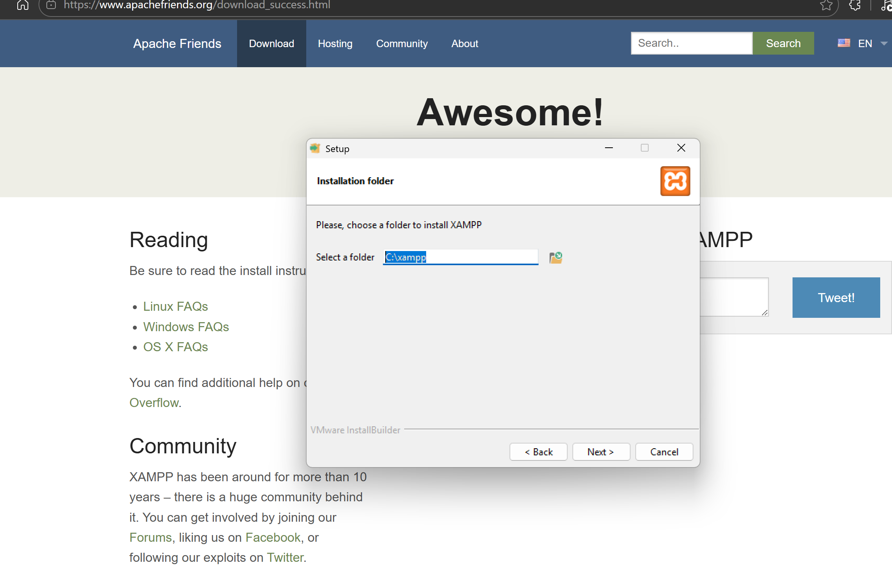
- after than click on next and allow installation
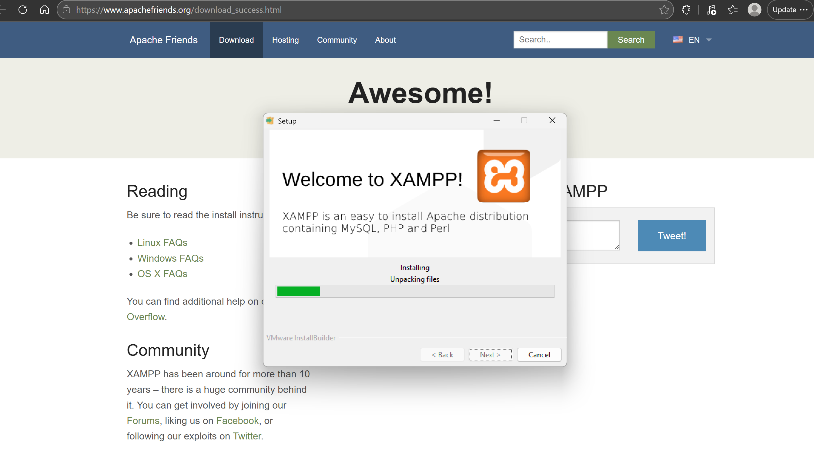
- xampp is now installed you need to provide some permission to make it work

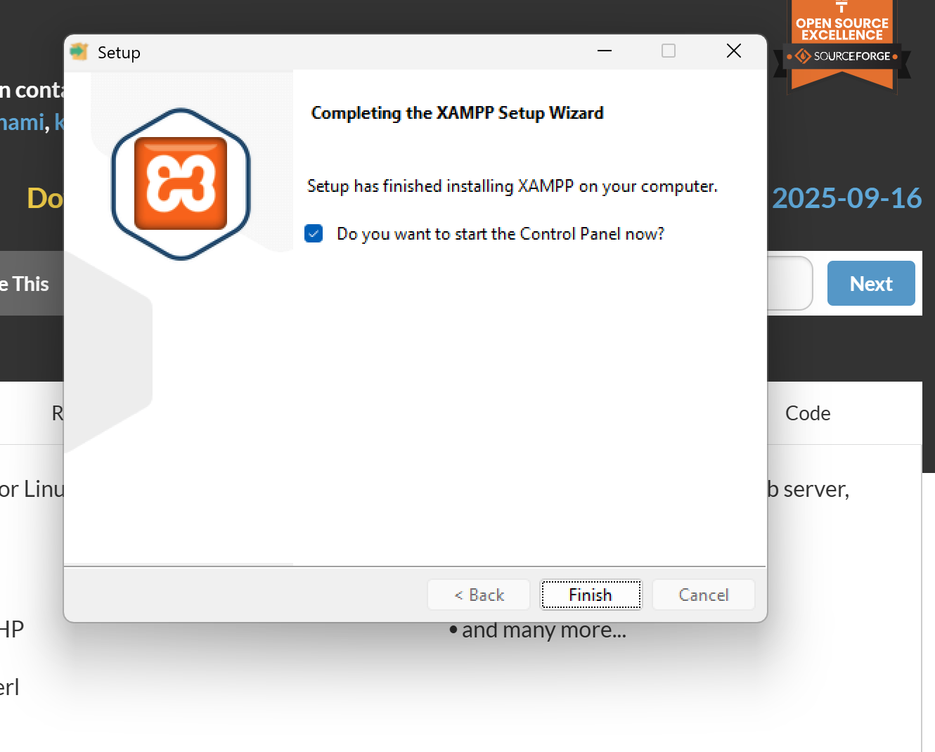
- xampp is now installed now you can see the control panel
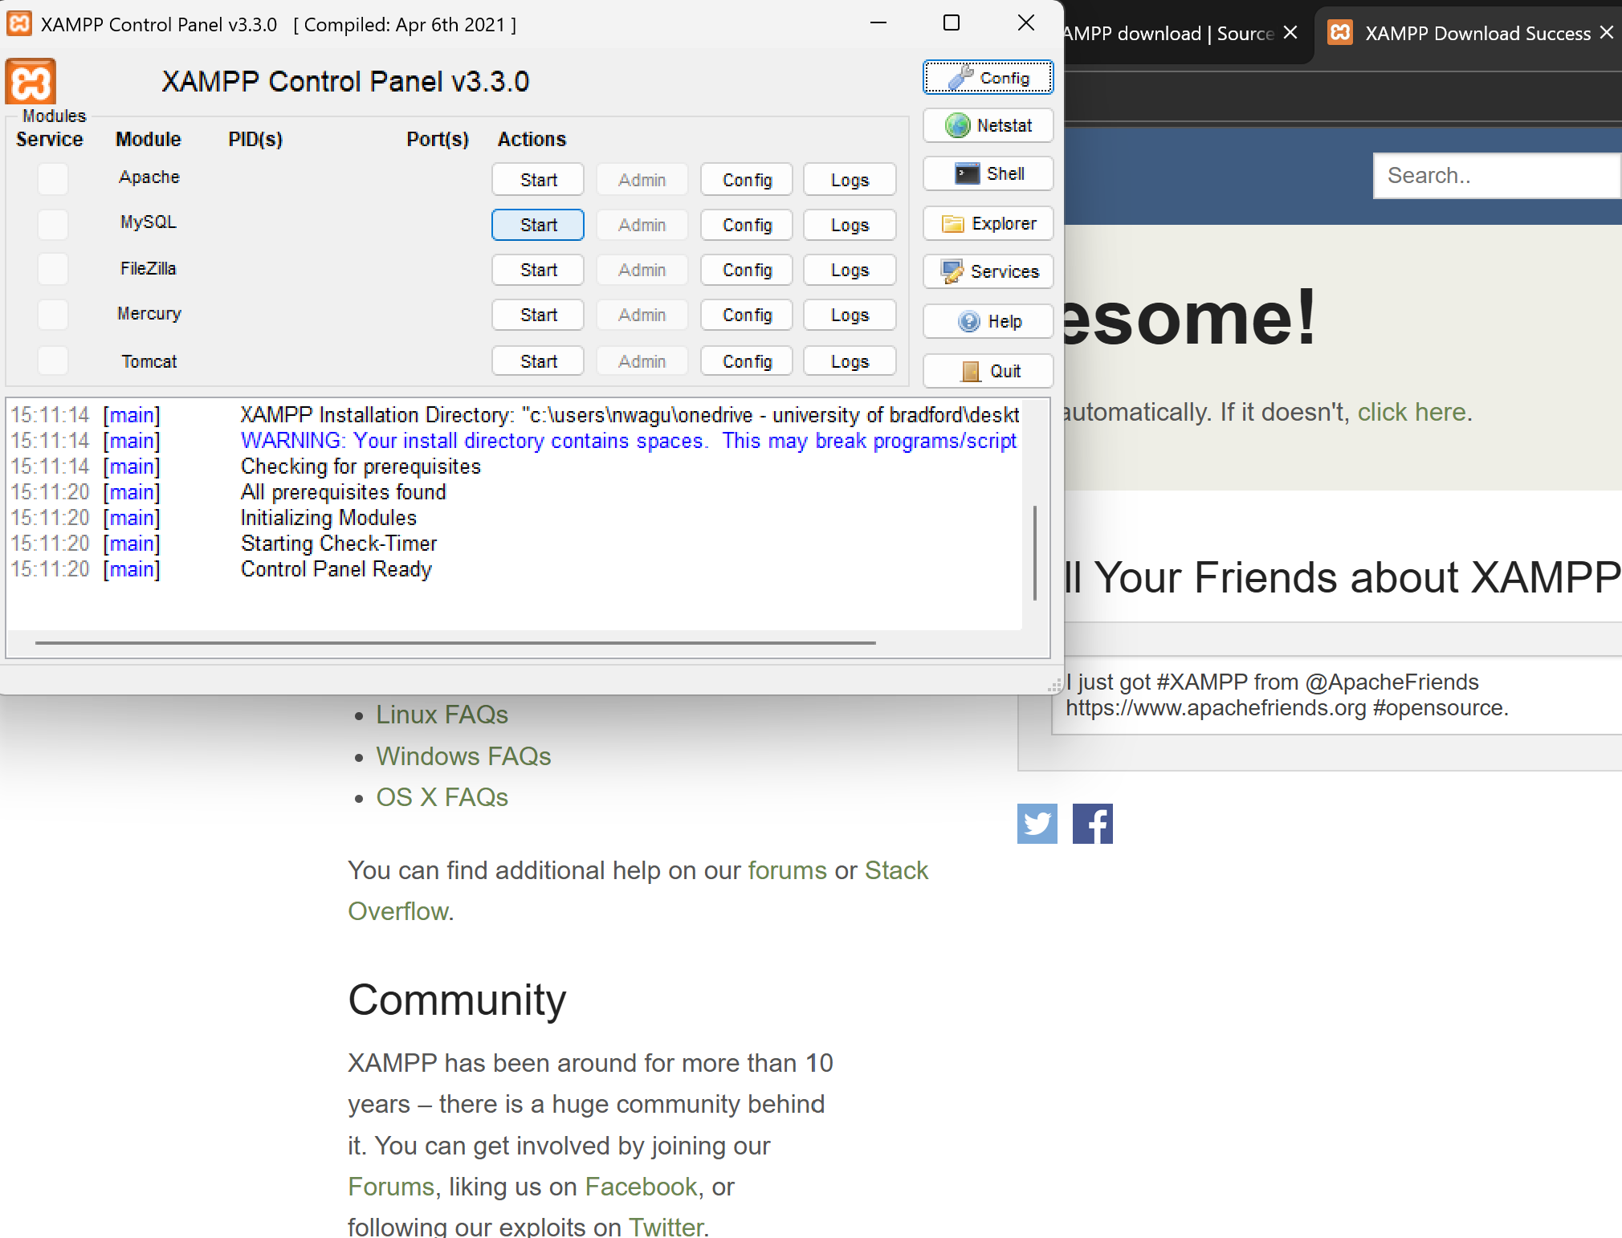
Conclusion
This application can be opened and edited using basic web files such as HTML and CSS, and in some cases SQL. Most changes can be made using a simple text editor and viewed in a browser. If you are new to web editing, start with small changes like updating text or colours before making larger layout or database changes.

